 | Mandatory disclosure updated on | 16-03-2018
1 | AICTE File no. | F.No.North-West/1-3329190004/2017/EOA
 | date and period of last approval | 10 April 2017 for A.Y 2017-18
2 | Name of the institution | Sat Priya Group of Institutions,Rohtak
 | Address of the institution | 0.5 K.M Milestone,Jind Road,Rohtak-124001
 | City & Pin code | Rohtak-124001
 | State/UT | Haryana
 | Phone number with STD code | +91-01262-290500
 | FAX number with STD code | +91-01262-290500
 | Email: | spiet2007@gmail.com
 | Website | www.Spgoi.com
 | nearest railway station(dis in KM) | Rohtak,3 K.M
 | Near bus stand | Rohtak
 | Nearest Airport(dist in km) | Indira Gandhi International Airport New Delhi, 70 KM
3 | Type of institution | Private-Self Financed/Unaided
 | Category(1)of the institution | Non Minority
 | Category (2) of the institution | Co-Education
4 | Name of the Organization running the Institute | Sat Priya Mehamia Memorial Educational Trust, Rohtak
 | Type of Organization | Educational Society
 | Address of Organization | 0.5 K.M Milestone,Jind Road,Rohtak-124001
 | Registered with | 3882
 | Registration date | 27-07-1998
 | Website of organization (society of | www.spmmet.com
 | trust website)
5 | NAME of the Affiliating university | Maharshi Dayanand University, Rohtak
 | Address | Delhi Road, University Secretariat,
 |  | Rohtak, Haryana 124001
 | Website of the university | www.mdurohtak.ac.in
 | Latest Affiliation Period | 2017-18
6 | Name of Director/Principal | Dr. Hitesh Kumar Dhal
 | Exact-Designation | Director
 | Phone No. with STD Code | +91-01262-290500,8222931604
 | Fax No. with STD Code | +91-01262-290500
 | E-Mail Id | hitesh_dhall001@yahoo.co.in
 | Highest Degree | Ph.D
 | Field of Specialization | Computer Science

7. Governing Board Members list:
S.No. | Name of the Directors/member | Designation
1 | Mr.Mukesh Arya | Chairman Trust
2 | Mr.Anil Kumar Arya | Trustee
3 | Mr. Sunil Kumar Arya | Trustee
4 | Mr. Rakesh Kuamr Arya | Trustee
5 | Mr. Seema Arya | Trustee
6 | Mr. Sahil Arya | Trustee
 | Frequency of Governing Body Meeting and  Date of last Meeting | Twice in a year,  21/02/2018
8. Academic Advisory Body-
Name | Designation
Mr. Mukesh Arya | Chairman
Dr. Hitesh Kumar Dhal | Director
Dr. Dolly Dhal | HOD & Professor
Dr. Sangeeta Malik | HOD &Associate Professor
Ms. Rupali | HOD &Assistant Professor
Mr. Rajender Kashyap | HOD &Assistant Professor
Mr. Pardeep | HOD &Assistant Professor
Ms.Taruna Sikka | HOD &Assistant Professor
Ms.Isha Sharma | Assistant Professor
Ms.Neha Dhankhar | Assistant Professor
Mr.Manish | Assistant Professor
Frequency of Governing Body Meeting and  Date of last Meeting | Twice in a year,  21/02/2018

9. Organization Chart-

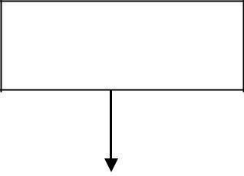
TRUSTEES

GOVERNING BODY |  | CHAIRMAN |  | COMMITTEE MEMBERS
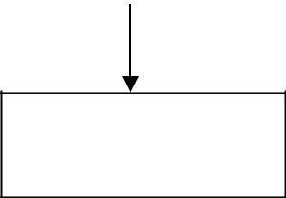

DIRECTOR

TEACHING STAFF
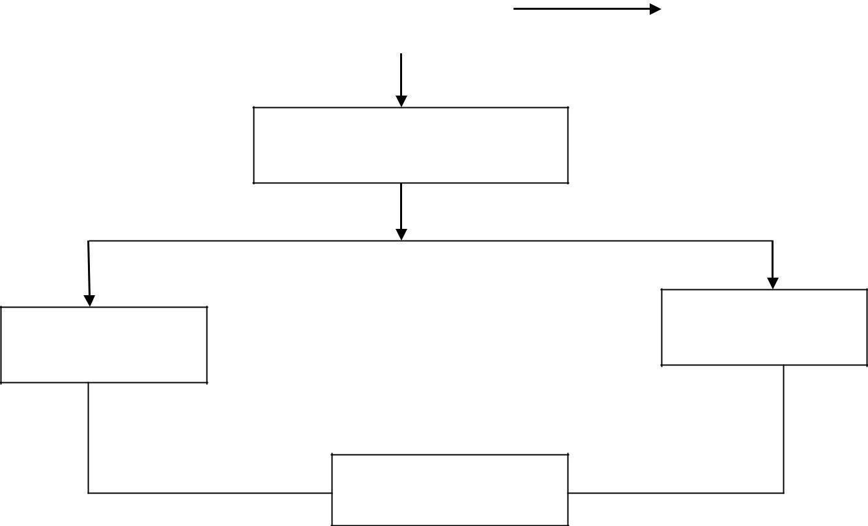
DIRECTOR

OFFICE SUPERINTENDENT

ACCOUNTANT
SENIOR CLERK

OFFICE ASSISTANT

Student feedback mechanism on  Institutional Governance/faculty  performance |  | Online Feedback System
10 | Name of the Department | Management
 | Course | MBA
 | Level | POST GRADUATE
 | 1st year approval by the council | 2007
 | Sanction Intake | 60

11 | Name of the Department | Computer Science
 | Course | MCA
 | Level | POST GRADUATE
 | 1st year approval by the council | 2008
 | Sanction Intake | 60

12 | Name of the Department | Computer Science and Engineering
 | Course | M.tech (computer science &  Engineering)
 | Level | POST GRADUATE
 | 1st year approval by the council | 2011
 | Sanction Intake | 18

13 | Name of the Department | Mechanical Engineering
 | Course | M.TECH ( Mechanical Engineering )
 | Level | POST GRADUATE
 | 1st year approval by the council | 2013(Second Shift)
 | Sanction Intake | 24

14 | Name of the Department | Civil Transportation Engineering
 | Course | M.TECH (Civil Transportation Engineering)
 | Level | POST GRADUATE
 | 1st year approval by the council | 2014
 | Sanction Intake | 24

15 | Name of the Department | Electronic & Communication Engineering
 | Course | M.TECH ( Electronic & Communication Engineering )
 | Level | POST GRADUATE
 | 1st year approval by the council | 2013
 | Sanction Intake | 24(Second Shift)
16 | Name of the Department | Computer Science and Engineering
 | Course | B.TECH (Computer Science & Engineering)
 | Level | Under Graduate
 | 1st year approval by the council | 2007
 | Sanction Intake | 60
17 | Name of the Department | Mechanical Engineering
 | Course | B.TECH ( Mechanical Engineering )
 | Level | Under Graduate
 | 1st year approval by the council | 2007
 | Sanction Intake | 60
18 | Name of the Department | Civil Engineering
 | Course | B.TECH (Civil Engineering)
 | Level | Under Graduate
 | 1st year approval by the council | 2010
 | Sanction Intake | 60
19 | Name of the Department | Electronic & Communication Engineering
 | Course | B.TECH ( Electronic & Communication Engineering )
 | Level | Under Graduate
 | 1st year approval by the council | 2007
 | Sanction Intake | 60

20. Infrastructure Information :
Classrooms / Tutorial Room Facilities:-
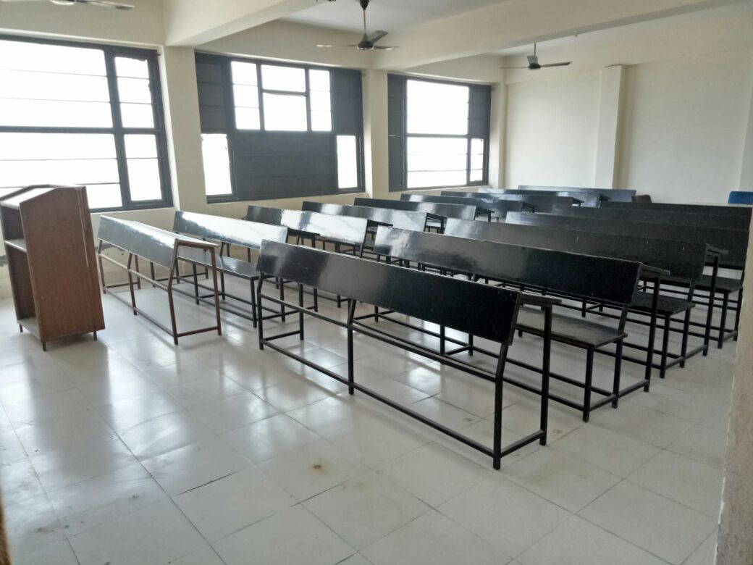
20(A) Computer Centre Facility:-
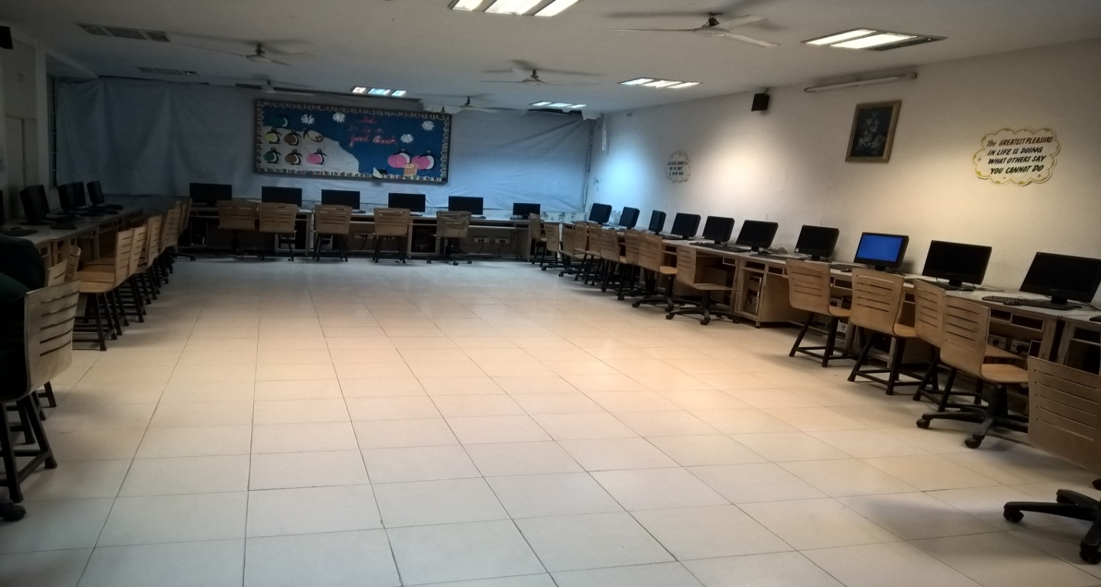
20(B) Library Facilities:-
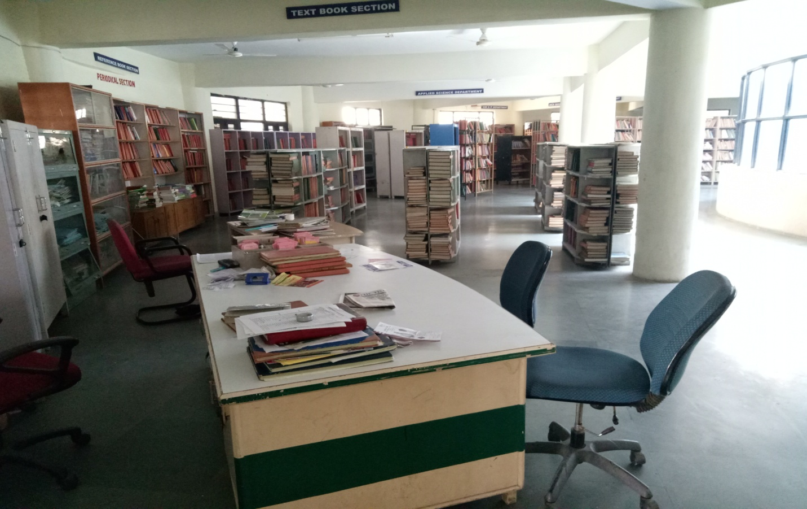
20 (c)Indoor Sports Facilities :-
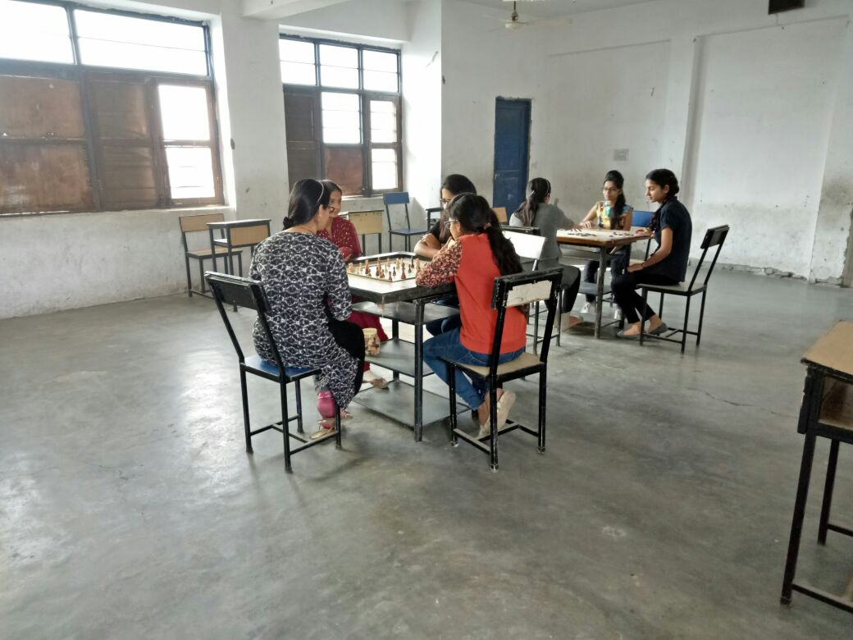
20(D) Ground Sports Facilities:-
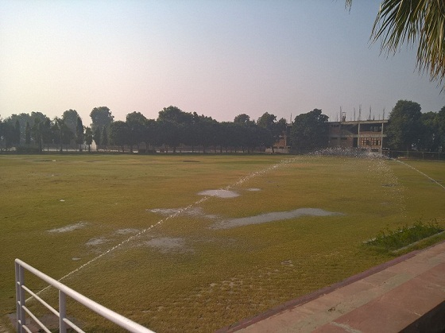

21 | Hostel | -
22 | Academic Sessions | As per AICTE, DTE
23 | Counseling / Mentoring | Yes
 | Career Counseling | Yes
 | Medical facilities | Yes
24 | Students Activity Body | Yes
 | Cultural Activities | Yes
 | Sports Activities | Yes
 | Literary Activities | Yes
 | Magazine / Newsletter | Yes
 | Technical activities / TechFest | Yes
 | Industrial Visits / Tours | Yes
 | Alumni activities | Yes

